**Manual of the CF2LogSP3i3_6**

(04/19/2017)

**CF2LogSP3i3_6 (6/12/2016) Current**

­Revision history

1. Fixed the issue of system reboot when mounting a large CF card (>256GB) mounting. Changed BIRCFRecorder3.c to BIRCFRecorder4.c. It prevents from rebooting while checking free space of a large CF card (e.g., 512 GB) by asserting TickleSWSR(). In BirSetupNextVolume, PITAddChore(PetWDog, WD_Int_Lvl) was added. With this, TickleSWSR is issued at 13-sec interval which prevents from rebooting during the long drive free space search.
2. Still logging with 2-channel at 32 kHz sampling reboots in about 10-12 days. No solution yet.
3. CF cards are accessed as d: e: f: g: h: i: j: k: drives (same as 3_5).
4. SYS.F32TRUST=* can still be used to speed up the directory search. It only helps if the system never reboots. It does not harm the system or stops the program.

**CF2LogSP3i3_5 (7/08/2015)**

Revision history

1. CF cards are now accessed as d: e: f: g: h: i: j: k: drives. No more confusion on the drive names, which was used to be d: and e: only regardless of the current BIR.CURBIA.
2. SYS.F32TRUST=* can be used to speed up the directory search when the drive is mounted. But it speeds up only when reset=0. Once reset occurs, however no quick drive mounting and system reboot occurs if the drive is larger than 256 GB.
3. 512 GB CF cards can be used on multiple BigIDEs with SYS.F32TRUST=* option. But If system reboots once, drive info is gone, and no quick drive mount. The watch dog period is 419 sec (7 min) which expires during the 512 GB card free space search period. As a result, the system keeps rebooting and logging never re-starts.

**CF2LogSP3i3_4 (7/30/2015) (DO NOT USE THIS PROGRAM)**

Revision history

1. Up to 3_4 revision all drives are mounted as either d: or e: drive. This is the root of the problem that the logging stops at BigIDE #1, if SYS.F32TRUST=*. Since the program uses only the two drive letters (D: and E:) regardless of which BigIDE that CF card is mounted, it confused with the previous D: and E: drives and assumes that they are full and stops logging. As a result, logging stopps.
2. Added TickleSWSR between drive changes so that CF2 won’t reboot. (7/11/2015)

2. Implemented a watch dog with 419 sec timer. (4/12/2014)

3. Implemented low-power SleepUntilWoken after disks are full. It waits for your keyboard stroke to end the program.

4. Added a safety net to check if BIR.CURBIA and BIR.CFDOSDRV are not consistent.

5. Checks if the CPU clock speed is correct for the sampling rate.

6. If it reboots occurs during the slave card logging, it correctly mount both master and slave, and does not draw 20 mA excess current.

**CF2LogSP3i3_4A (7/30/2015)**

Same as 3_4 except 1) it works with Q-Tech clock as cpu clock source, 2) Set clock by POP pulse from the Spectrum GPS, and measure the clock error by Event Trig.

**CFxLgSP3i3_3**

Fixed the excess current consumption issue (20 mA more) when writing to the BigIDE slave. It mounts both master and slave as D: and E: with 1 mA more current (@15V) than on C: drive. The same program works on three different DAQ boards including 1) DAQ2 with modifications (DAQ2D), 2) SmlDAQ and 3) CSACDAQ. Work with multiple BigIDEAs with double CF card slots with SYS.F32TRUST= option.

**CFxLogSP3i3_2.c (4/19/2013**) Use this for C: drive logging for the CF card =<128 GB with 100 MB/sec speed.

For H3DAQ2 (DAQ2D), SMDAQ or CSACDAQ (>=Rev 3). For CSACDAQ, it is only for CF2 with a 3-pin clock jumper soldered. Refer to CSACDAQ manual for this. It is primarily for the C: drive logging, however it can still used with BigIDEA multiple CF cards logging. For D: drive logging, set J6 jumper to D: Log the data to D: drive only. When slave becomes E:, it draws 20 mA excess current. Works fine with a single slot IDE-CF card adopter. Works with multiple BigIDEAs with a single slot CF card adopter with SYS.F32TRUST= option.

**Data acquisition boards (DAQ)**

All boards use the CF2 from Persistor Inc. <http://www.persistor.com/>

1. **DAQ2D (modified DAQ2 board)**

To run CFxLogSPi# program, DAQ2 board requires two modifications, which is now called DAQ2D. Also pre-amp board needs changes on U8 and U9 to allow power turn on/off.

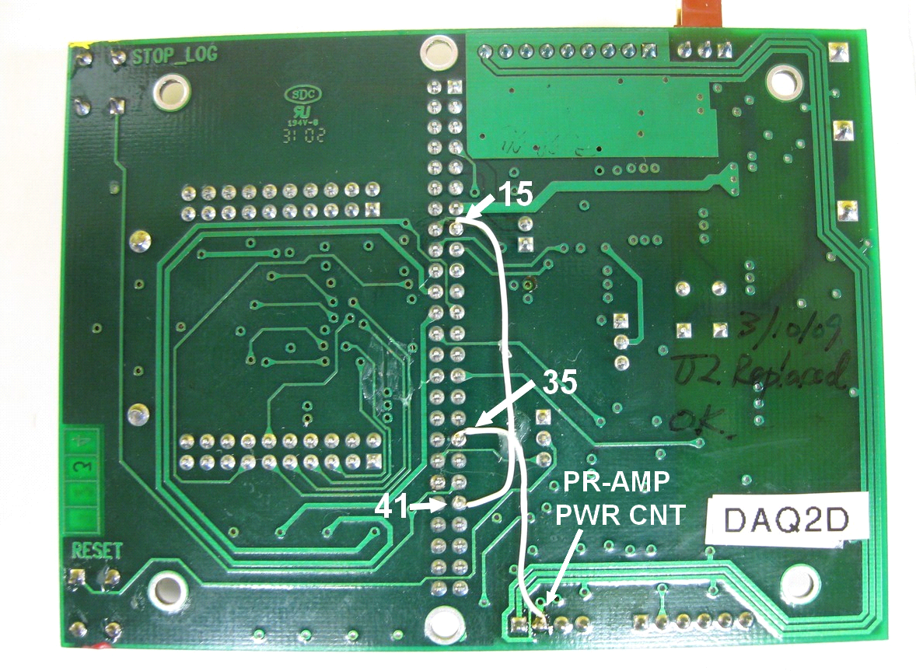

**Obsolete**

Fig. 1. DAQ2 modifications:

1. Connect pin 15 and 41 (for SPi A to D)
2. Connect Pin 35 to PWR CNT (for pre-amp power on/off)

1. Pin 15 (PCS) and pin 41 (IRQ2) to be connected.

2. Pin 35 is connected to pin 2 of pre-amp's J2 (2.5V ext) to turn on/off the pre-amp or external device. You have to snip off the EXT pin on J12 to avoid an accidental short.

** **Cautions\***\*\*\*\*\*\*\*\*\*\*\*\*\*\*\*\*\*\*\*\*\*\*\*\*\*\*\*\*\*\*\*\*\*\*\*\*\*\*\*\*\*\*\*\*\*\*\*\*\*\*\*\*\*\*\*\*\*\*\*\*\*\*\*\*\*\*

Not to use a regular pre-amp without power control changes on the board. Also turn on the pre-amp before powering DAQ board. SCR latch may occur if A/D input voltage is >2.8V or < -0.3V. If this happens, A/D freezes (constant values), and only way to recover from this situation is to power on/off the DAQ board. A simple reset does not fix this.

**2) SmlDAQ**

On the SmlDAQ, jumper at J6 should be D: position (short upper 2 pins) if you use the BigIDE as D: and E: drive. C: is reserved for onboard CF card logging on CF2 as a C: drive. Short J3 is for the normal operation without magnetic ON/OFF switch. For details see SmlDAQ manual. J3 should be open when to use the magnet power on/off switch such as FODH. J1 (MGSW) is for the magnet switch. Short unused A/D signal inputs at ADIN. Supercap is a power reserve when the power is interrupted by magnetic switch so that it has enough power to close the file on the CF card for a few seconds. If no magnetic switch, the Supercap is not needed.

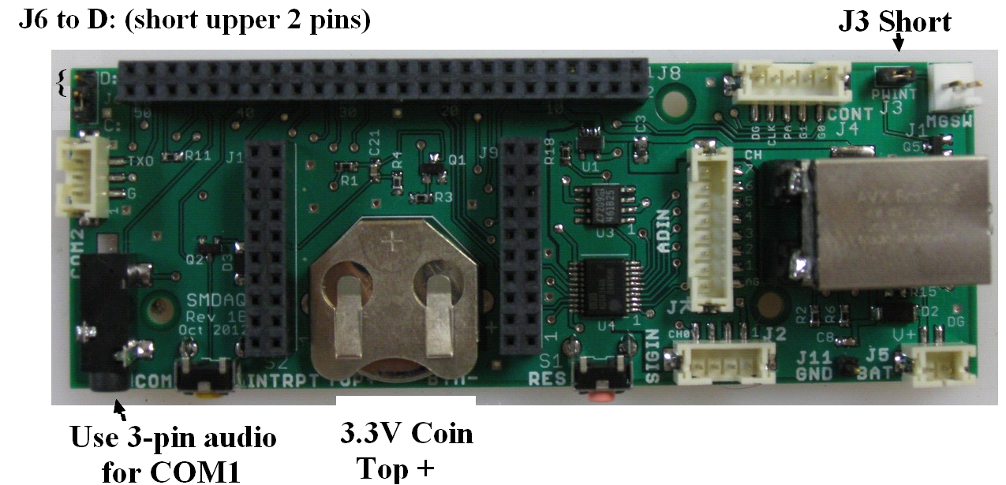

Fig. 2. SMLDAQ jumpers

**3) CSACDAQ and CF2**

CSACDAQ can be used with or without the CSAC clock.

**To use CSAC clock as an accurate source of timing signal**-

When the CSAC clock is installed CF2’s CPU can use the CSAC’s 40 kHz pulse as a clock. To do this, you need a modification on the backside of CF2 computer board. Remove the 0 Ohm resistor on the left and either re-solder it on the right side or solder a 3-pin jumper. Set a jumper according to the clock signal source (right side-external clock, left: internal 40 kHz crystal). On the CSACDAQ board set a jumper on “Ext” (P5 connector). Timing accuracy is 10-100 msec/year but it draws 13 mA excess current in addition to what the logging program draws.

**Without CSAC clock-**

If you use the CF2 crystal as a clock signal, set a jumper to the CF2 side to rely on the internal real-time clock (RTC). Timing accuracy would be ~1 sec/day. No excess current draw by using RTC with internal X’tal.

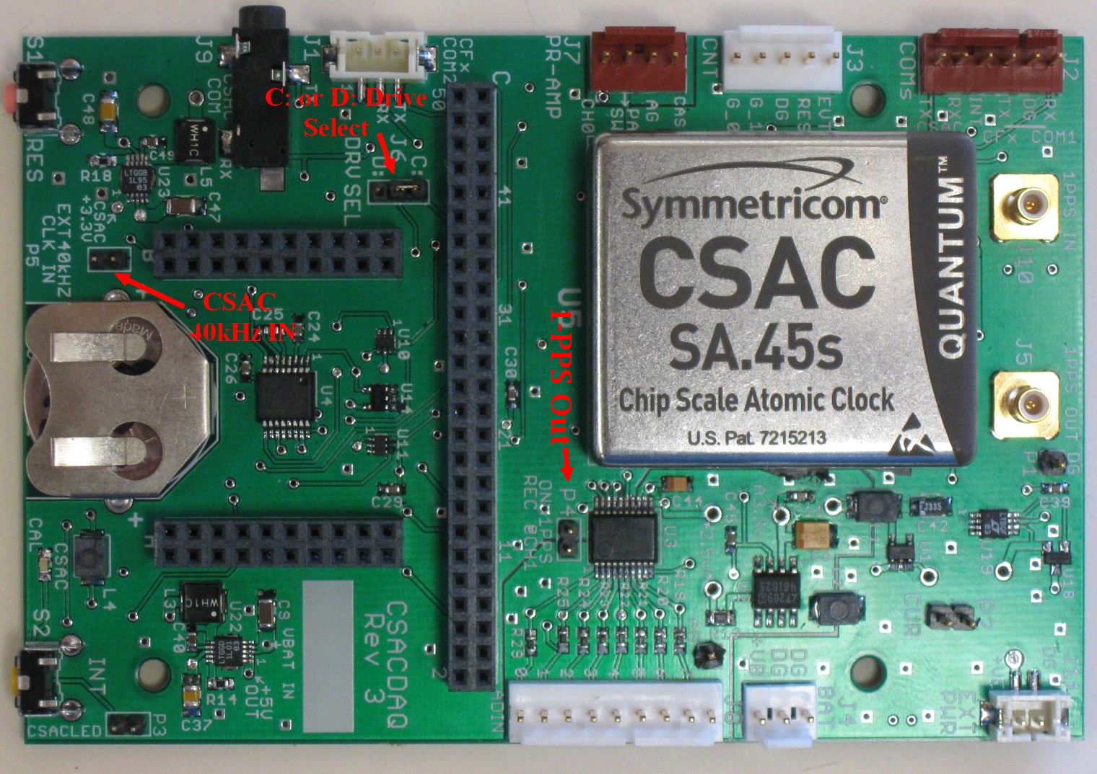

Fig. 3. CSACDAQ jumper settings. For BigIDEA CF card logging set J6 to D:

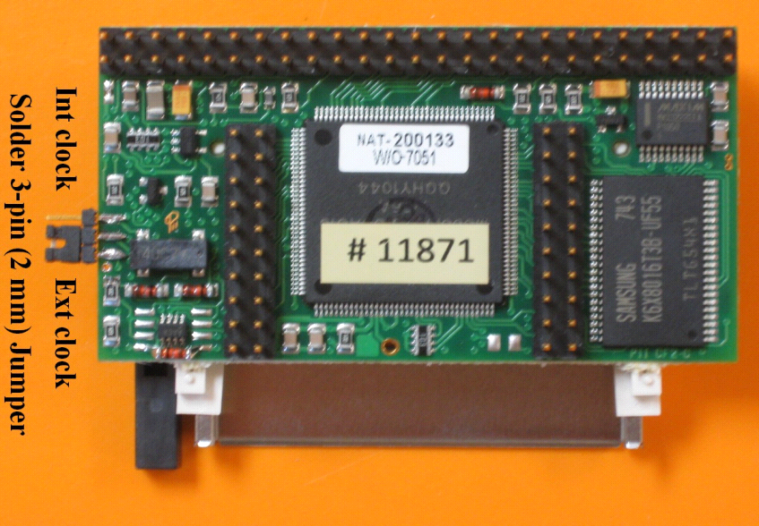

Fig. 4. CF2 back plane: There is a 3 solder pads on the lower edge. For internal clock short left (default). For external clock you must short right side. You must short the P5 jumper on the CSACDAQ as well for the external clock. Instead of the 3-pin jumper, you can solder the 0 Ohm resister.

When using CSACDAQ with BigIDE cards, set J6 to D: drive logging. If logging to the onboard C: drive, move the J6 jumper to C:. Again there are two 40-kHz clock source options: 1) use the accurate CSAC clock and 2) use the internal less accurate clock.

**Option (1)-** **Use the accurate CSAC clock**. Caution! It uses 13 mA more current at 12 V. CASCDAQ can take the CSAC’s 40 kHz clock pulses to clock the CF2’s CPU as well as keeping the accurate time of onboard RTC. CSAC pulses can maintain the CF2’s RTC clock accurate to 1 ms/year (theoretical). But drawback is an excess 13 mA (100% duty cycle) current is required to power the CSAC. Here is what you have to do:

* Persistor’s CF2 board must be modified to take the 40-kHz external clock as an input. Refer to CSACDAQ manual. Set the jumper appropriate setting.
* CSACDAQ jumper P5 must be shorted. CSAC must be disciplined for at least 6 months on the bench and CF2’s RTC clock has to be set by another program before launching the program. If you wish to record the 1-PPS, set ACQ.NCHAN=2 so that it records the 1-PPS on chan 1 (second channel). Chan 0 is for acoustic signal with 0 to 2.5V range.
* Short the unused channels to the ground to reduce noise interferences. Do not short 1-PPS (P4-chan 1) if you are recording 1-PPS.

Option (2)- No CSAC. Unplug the CSAC and switch the 3-pin clock jumper on CF2 if it is installed. It uses the internal 40 kHz crystal oscillator, therefore uses less power but lower timing accuracy (approximately 1 sec/day). It may be necessary either to set the CF2’s jumper to internal clock or solder the 0 Ohm resistor to take the crystal oscillator’s pulse.

* CSACDAQ jumper P5 open.
* No 1-PPS recording. P4 Open. (remove the jumper) and short the channel to ground to reduce the noise.

**About the CF card adopter**

Note that a LED light (one LED if single two with double slot) uses about 2 mA additional current. To save power, unsolder a resistor by the LED.

**What CF2 program would do:**

It writes the data to the CF card mounted on the IDE card adopter which is mounted on the BigIDE by a ribbon cable. It takes either single or dual slots IDE adopter. If it is a dual, the first BigIDE’s master slot is D: and slave slot is E:. If it is a single CF card adopter, it is treated as a master D:. **Cautions**- Because of a slight difference in FAT32 of PicoDOS from the MS DOS, **each CF card must be formatted by PicoDOS FORMAT command even if it had been pre-formatted in MS DOS Fat32.**

To mount the CF card on the BigIDE drive(0), on Motocross window, mount the **master** CF card on BIADRIVE 0 as D: and slave drive as E: You can mount both drives at the same time by

mount d: bfcm-0

mount e: bfcs-0

dir d:

dir e:

You must specify the drive letter (e.g., D: and E for BIADRIVE 0) in your mount command. To take advantage of SYS.F32TRUST=* option for a quicker free space search, you must “dir” with d: or e:. Once you do this for each drive, CF2 remembers the file structure.

To mount the CF card on the second BigIDE drive (1)

mount f: bfcs-1

mount g: bfcm-1

If you have more than two BigIDEs, mount the CF card according to the following rule:

BIR.CURBIA 0 1 2 3 4

Master D F H K L

Slave E G I J M

**DAQ board types**

Also you have to set ACQ.DAQ to let CF2 know what DAQ board you are using. If you do not, it gives an error message and aborts the program. Set ACQ.DAQNAME as one of the followings H3DAQ, SMDAQ, or CSACD.

ACQ.DAQNAME=H3DAQ

You also have to define DAQ in the CFxLogSP3i3_3.c as well (line 144) and **recompile** it.

#define DAQ1 for ACQ.DAQNAME=H3DAQ

#define DAQ2 for ACQ.DAQNAME=SMDAQ

#define DAQ3 for ACQ.DAQNAME=CSAC

Launch the new *.run program. Then set acq.startups=0, reset, stop the program by hitting ‘.’ Run the “setting program” by typing ‘s’ in order to create new set parameters. Set parameters need to pay attentions are

BIR.CURBIA= 0 : starting BIA drive number **(1-st drive is 0)**

BIR.BIADEVICE = 3 : 3 is master & always at the init startup **(important)**. 4 is slave.

BIR.CFDOSDRV =D: : logging starts with master D: drive (!**important).** Slave is E:.

ACQ.STARTUPS =0 : always!

ACQ.MAXSTRTS = 99 : some reasonable resets number

ACQ.HYDROSN = #### : hydrophone serial number

ACQ.ACTIVESEC =3600 : active logging duration in sec **(NEW)**

ACQ.DUTYCYCLE =3600 : duty cycle (continuous ACTIVESEC=DUTYCYCLE) **NEW**

BIR.CFPPBSZ = 0 : no longer used

ACQ.WARUP = 5 : data logging delayed for this sec to warm-up pre-amp **NEW**

ACQ.SLEEP = #### : hours of sleep before the logging starts

SYS.F32TRUST=* :This makes the free space search quicker if the acq.startups=0. “Dir” listing takes a long time especially a 512 GB drive**.** If you do “dir” for each drive (d:, e:, f:, g: h:, i: etc) before launching the program, CF2 remembers the free space, and mounting the disk goes faster. You can take advantage of this feature for the drives less than 512 GB as well. However if CF2 reboots once, it loses the free space info and ‘dir’ process takes long, and loses the benefit of short access.

**SYS.F32TRUST= F**ree space search takes longer. You do not need “dir” with this option.

For the CF cards smaller than or equal to 256 GB with multiple BigIDEAs system, you can set SYS.F32TRUST= (blank, just carriage return). You can also mix CF cards of different sizes.

For PicoDOS operating system 4.03r1, the 128-GB CF card is the maximum size that it can handle. For the CF cards larger than 128 GB, burn the “Beta” version of PicoDOS. Maximum CF card available now (7/27/2015) is 512 GB from Lexar.

**Caution!!** If you set SYS.F32TRUST=(blank, just carriage return), searching free space takes ~8 minutes for 512 GB card, ~4 min for 256 GB, and ~2 min for 128 GB. The watch dog reboots the CF2 in 7 minutes (419 sec) and logging never starts. SYS.F32TRUST=* speeds up the free space search when the new drive is mounted, which in general takes less than 10 seconds. (This bug was fixed in CF2LogSP3i3_6 and later versions.)

**Cautions (Important)!!!**

Largest CF cards so far have been tested are SanDisk (256 GB or less) and Lexar (128 GB or 512 GB). CF cards have to be fdisked and formatted by PicoDOS. Each card has to be “dir” before launching the program. Formatting a CF card larger than 134 GB, you must use the **PicoDOS beta version.**

**Multiple BigIDEs** **system**

When you run the program for the first time, you must choose ‘s’ to set the VEE parameters (e.g., ACQ, BIR, and SYS parameters), the default is

SYS.F32TRUST=* speeds up the free space search. You must mount each drive with different name (d:, e:, f:, g: etc) and do “dir” for all drives.

SYS.F32TRUST= can be used only for the CF cards smaller or equal to 256 GB. You do not need to mount each system and do “dir”. CFs thinks it is a fresh mount and it does take a long time to do free space search, CF2 would not reboot. It takes approximately 2 min per 128 GB when the CF card is mounted for the first time. It is still shorter than the watch dog timer (419 seconds) and logging will continue. On the other hand if the drive is 512 GB, it takes ~8 minutes (~480 sec) and CF2 will reboot before the search is done and the logging would never start. This bug was fixed in CF2LogSP3i3_6.

**Example two BigIDE system with 512 GB CF cards**

1. **You must burn the beta version of PicoDOS.**
2. **You must set SYS.F32TRUST=\***
3. **After setting above, mount the master card as**

**Mount D: bfcm-0 (you must specify drive letter D:)**

**And ‘dir d:’**

1. **Mount E: bfcs-0 (You must specify drive letter E:)**

**And do ‘dir E:’**

1. **Mount f: bcfm-1**

**And ‘dir f:”**

1. **Mount g: bcfs-1**

**And ‘dir g:’**

If you erase any *.dat files on the drive or re-format the drive, you must repeat ‘dir “. Otherwise wrong free space is registered.

**Current usage (power consumption)**

Table 1. With the 15V or 12V battery current usages in mAHr for logging on a CF card mounted on BigIDEA

|  |  |  |  |  |  |  |  |
| --- | --- | --- | --- | --- | --- | --- | --- |
| Sampling Rate Hz (SysClk kHz) | Battery 15V  Linear  DAQ2D & SmlDAQ | Battery 12V  Linear  DAQ2D & SmlDAQ | Battery 15 V with DC-DC convertor  DAQ2D, SmlDAQ & CSACDAQ | Battery 12V with  DC-DC convertor with  DAQ2D, SmlDAQ  & CSACDAQ without ext clock | **12 V Pre-Amp** | **12 V Q-Tech** | **12 V CSAC** |
| Sleep mode | 0.9 | 1.1 | 0.5 | 0.6 | 0 | 3 | 13 |
| 250(640) | 4.5 |  | 3 |  | 6 | 3 | 13 |
| 500 (640) | 4.8 | 5.8 | 3.1 | 4 | 6 | 3 | 13 |
| 1kHz(640) | 5.3 | 6.8 | 3.5 | 4.5 | 6 | 3 | 13 |
| 2kHz(1600) | 6.5 | 8.4 | 4.1 | 5.2 | 6 | 3 | 13 |
| 5kHz(1600) | 8.1 | 11 | 5.0 | 6.3 | 6 | 3 | 13 |
| 10kHz(8000) | 11 |  | 6.9 |  | 6 | 3 | 13 |
| 32kHz(8000) | 23 | 38 | 12 | 15 | 6 | 3 | 13 |
| 64kHz(16000) | 32 | 38 | 16 | 20 | 6 | 3 | 13 |

Current usage comparisons with linear power supply and DC-DC converter in mA.

Below is the picture of 6-V DC-DC convertor. It converts 7-15V battery voltage to 6V for DAQ2 or SmlDAQ only. CSACDAQ has a built-in DC-DC convertor.

**DO NOT USE THIS MINI DC-DC CONVERTOR. IT FAILES BELOW 2 ºC.**

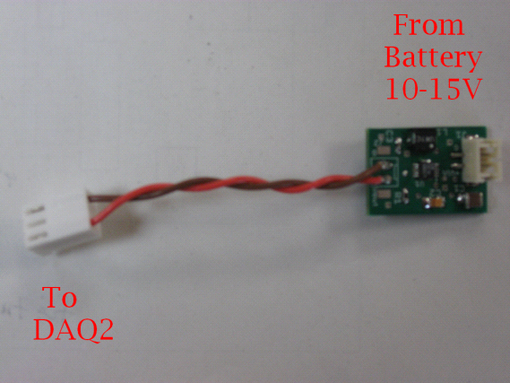

Fig. 5. 6V DC-DC power supply. For SmlDAQ and DAQ2 only.

If you are using DAQ2D or SmlDAQ, consider using a DC-DC convertor between the battery and DAQ board. Depending on sampling rate, it saves the power approximately by 30 to 55 %. CSACDAQ has a built-in DC-DC convertor, and the DC-DC convertor is not needed. There are several clock speed versions of CF2LogSP3i3_4 program under /bin***Hz depending on the sampling rate. For example, if the sampling rate is 5000 Hz, look under /bin5k. These programs are the same C program but compiled for a different CPU clock speed to optimize the speed and power consumption. If the program is compiled for 5 kHz sampling rate, you can use the same program for 250/500/1000/5000 Hz but not above 5 kHz.

**Caution!**

If you can, do not share the DC-DC power supply with pre-amp. Using the DC-DC output is noisy and tends to raise the noise level slightly.

**Battery life**

For the duration of deployment total mAHr requires is

Total current mAHr = Current x number of hours

D-cell battery has a current capacity typically 18,000 mAHr in room temperature. It decreases to about 15,000 mAHr at 5 oC and 12,500 mAHr at 0oC.

**Data logger:**

HARUIII-BAT10 digital side has 16 columns in parallel. The total current capacity is 240,000 mAHr (15000x16).

Number of days = total current capacity / (current usage x 24)

Example (With HARUIII_Bat 10)

@ 5 oC

32 kHz with Ic=15 mA

240,000/15/24 = 667 days

5kHz with Ic=6.3 mA

240,000/6.3/24=1587 days

@0oC

If the temperature is 0oC, D-cell capacity decreases to 12,500 mAHr.

32 kHz with Ic=15 mA

200,000/16/24 = 520 days

5kHz with Ic=6.3 mA

200,000/6.3/24= 1322 days

**Pre-amp**

6 x 10.5 V D cell Batteries- At 5 oC, 15000 x 6 = 90,000 mAHr. At 0 oC, 12,500 x 6= 75,000 mAHr. Current is 5 mA.

@ 5 oC

90,000/5/24= 750 days

@ 0oC

75000/5/24=625 days.

**Noise issue**

There are line noises associated with the sampling frequency. If it is sampling at 5 kHz, you will see a line noise at 1.25 kHz (1/4 of the sampling rate). If the sampling rate is 32 kHz, the line noise is at 8 kHz. 1.25 kHz line noise should be less than -60 dB (1 mV). You should measure the spectrum at the pre-amp output while logging program is running.

Unused A/D channels also contribute to the noise and should be grounded. One open A/D channel can increase the noise level significantly.

**Compact Flash Card (CF card) with BigIDEA**

Only Lexar or SanDisk cards work. Format (FAT32) each card by CF2’s PicoDOS command. Skipping this process would cause failure in logging. 128 GB, 256GB and 512 GB have tested so far. You need to test these cards with BIR.MINFREEKB, and make sure transitions from D: to E: and one BigIDEA to the following BigIDE occurs and log the data. You should run the test starting from one of slave drives (E:) if all the cards write the data.

**When using the CF2 out of box first time**

Normally CF2 uses its an onboard 40 kHz crystal to run its own clock to run the CPU. If the user chooses to run CF2 clock with more accurate oscillator such as CSAC clock or Q-Tech clock, 0 Ohm resister on the back plane (on the CF2 pic) has to be removed and P5 on the CSACDAQ must be shorted. With this the 40 kHz clock output from the CSACDAQ or Q-Tech board is connected to the CF2 clock input.

**Coin cell battery**

For each deployment, replace the 3 V coin cell (CR2032). It maintains the CF2’s real-time clock time when the main battery power is removed.

**Pre-Amp**

Compare with the picture below, make sure all the jumper settings are OK.

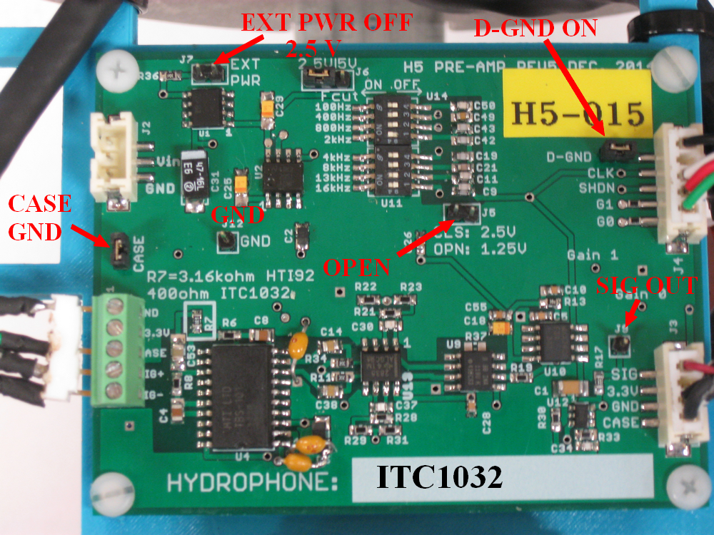

Fig. 6. H5 Rev 5 for ITC1032. Note that there is the same revision with 20 dB lower gain for HTI92 hydrophone. Note that there are six modifications on this pre-amp including four 0.1 uF ceramic caps and 10kΩ resistors at G0 and G1 for noise suppression. 4-th cap is on the backplane by 3.3V supply at hydrophone input.

The gain of the pre-amp above is optimized for ITC1032. Note that there is another version for HTI92 hydrophone which has 20 dB lower gain than the one for ITC1032. To minimize the system noise, connect all the ground lines including the signal and control. Routing the digital lines near the hydrophone input may raise the noise and should be avoided.

Without running the program you can control the preamp by executing PicoDOS TPU pin commands from the Motocross com terminal:

1. PS 35 to turn on the power. PC 35 to turn off.
2. PS 31 to make the G0=1
3. PS 32 to make the G1=1

Where PS is the command to set and PC is to clear the particular pin

|  |  |  |  |
| --- | --- | --- | --- |
|  | G0 | G1 |  |
| Gain\TPU pin | 31 | 32 | Gain [dB]  Table 2. TPU pins for pre-amp gain. PS 35 to turn on PC 35 to turn off. |
| 0 | 0 | 0 | 0 |
| 1 | 1 | 0 | 6 |
| 2 | 0 | 1 | 12 |
| 3 | 1 | 1 | 18 |

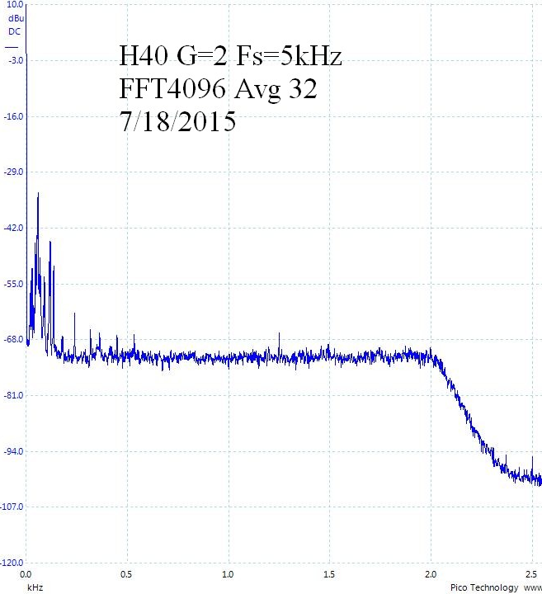

Fig. 7. Example of noise spectrum of the room while CFxLgSP3i_3_4 is running. With G=2, Fs=5 kHz, anti-aliasing at 2 kHz., ITC1032 hydrophone. H5 Rev 5 room noise level is ~ -74 dB. Signal is measured at the pre-amp output by PicoScope 4096 FFT 32 average.

**Tests need to be done before shipment**

1. Before running the logging program, test the pre-amp. Turn on the power by PS 35. Change the gain from 0, 1, 2, and 3 and observe the noise level goes up by 6 dB for each increment. Make sure that cut-off frequency is correct.
2. Run the logging program. Confirm if the transition from the drive d: to e: and BigIDE 0 to 1, f: to g:, BigIDE 1 to 2, h: to i:, & etc occur. Set the BIR.MINFREEKB to an appropriate value and ACQ.ACTIVESEC and ACQ.DUTYCYCLE to small values so that the test would complete in a short period (e.g., write one short file 60-180 sec long). Also you can use a first sampling rate, e.g., 32000.
3. Using PicoScope, evaluate the noise spectrum at the pre-amp output to make sure there is no excessive high system noise.
4. Evaluate the spectrum of the logged data.
5. Measure the current consumption for each system. They may be different from the nominal value. Calculate the battery life yourself and make sure that the battery would last for the duration of deployment. Measure the pre-amp and data logger’s current consumption separately.
6. Log the data starting from E: drive instead of D: drive., e.g., CURBIA=0, CFDOSDRV=E: and BIADEVICE=4.
7. Don’t forget to set BIR.MINFREEKB=0, ACQ.ACTIVESEC, DUTYCYCLE, SRATEHZ back to the normal values.
8. Don’t forget to dismount each disk by mount *** /d.